|  |
| --- |
| **LAB 4** |
| SOAP AND RESTFUL SERVICES |
|  |
| [Type the abstract of the document here. The abstract is typically a short summary of the contents of the document. Type the abstract of the document here. The abstract is typically a short summary of the contents of the document.] |
|  |
| **Karthik Repala** |
| **9/23/2013** |
|  |

**SOAP WEB SERVICES**

Creating a Web Service Application-

Go to File-New Project

Right Click on the project and click on Add new Item and Select the Web Service Application.

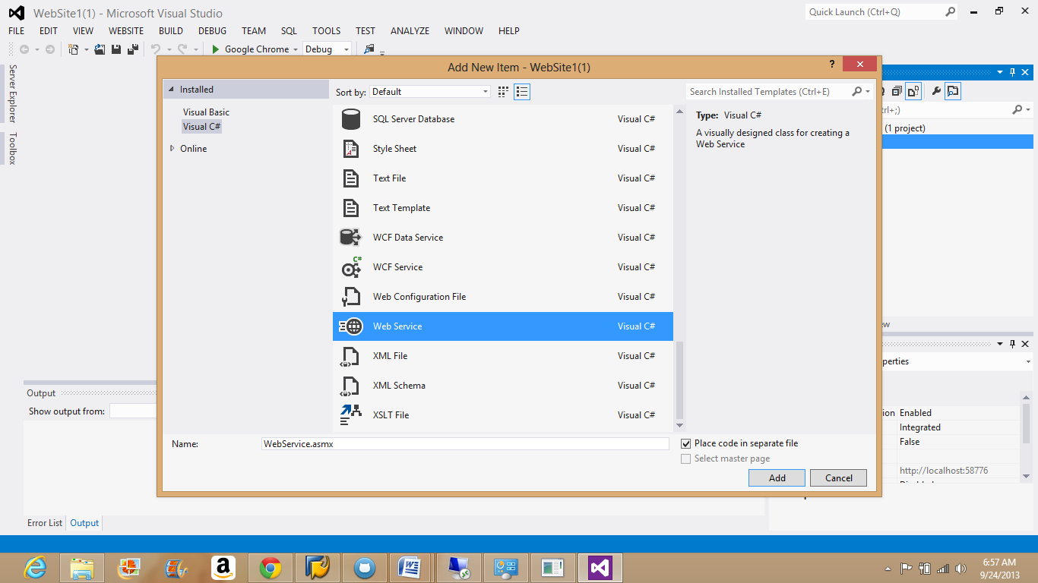

Write the required code in the editor shown below.

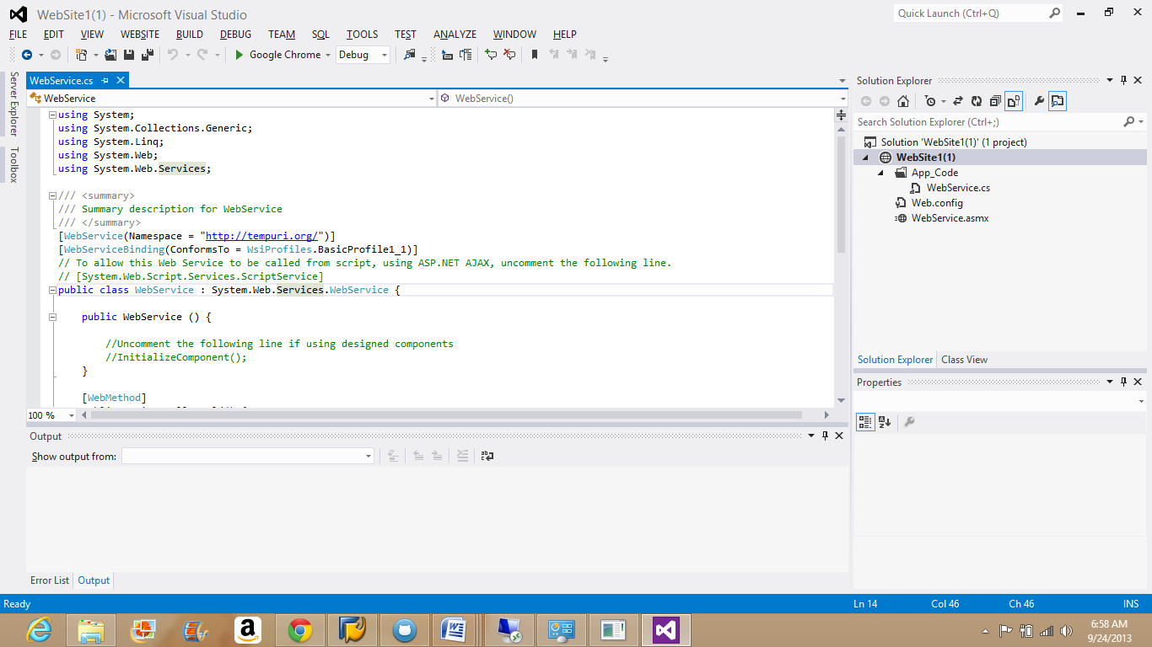

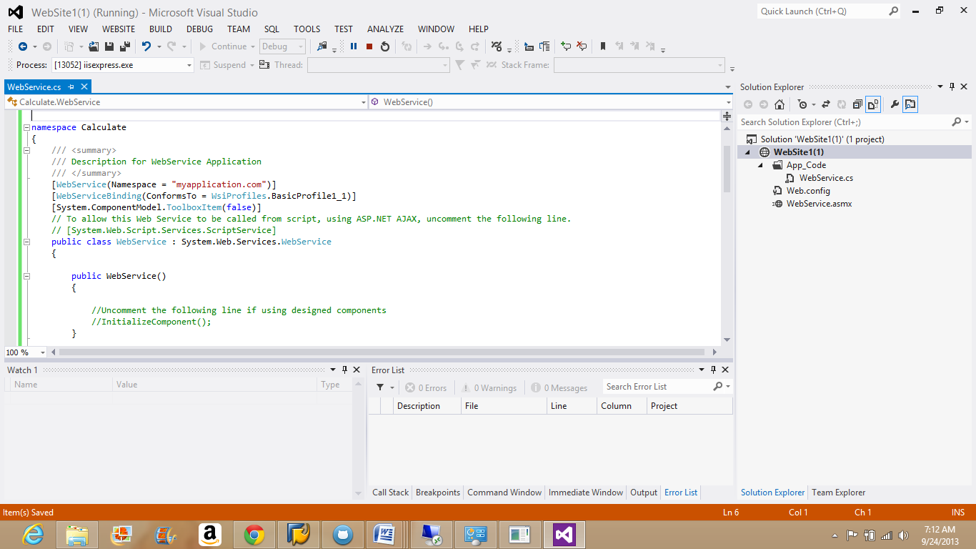

Build the code after finished with coding.

Go to Menu Build-Build Solution.

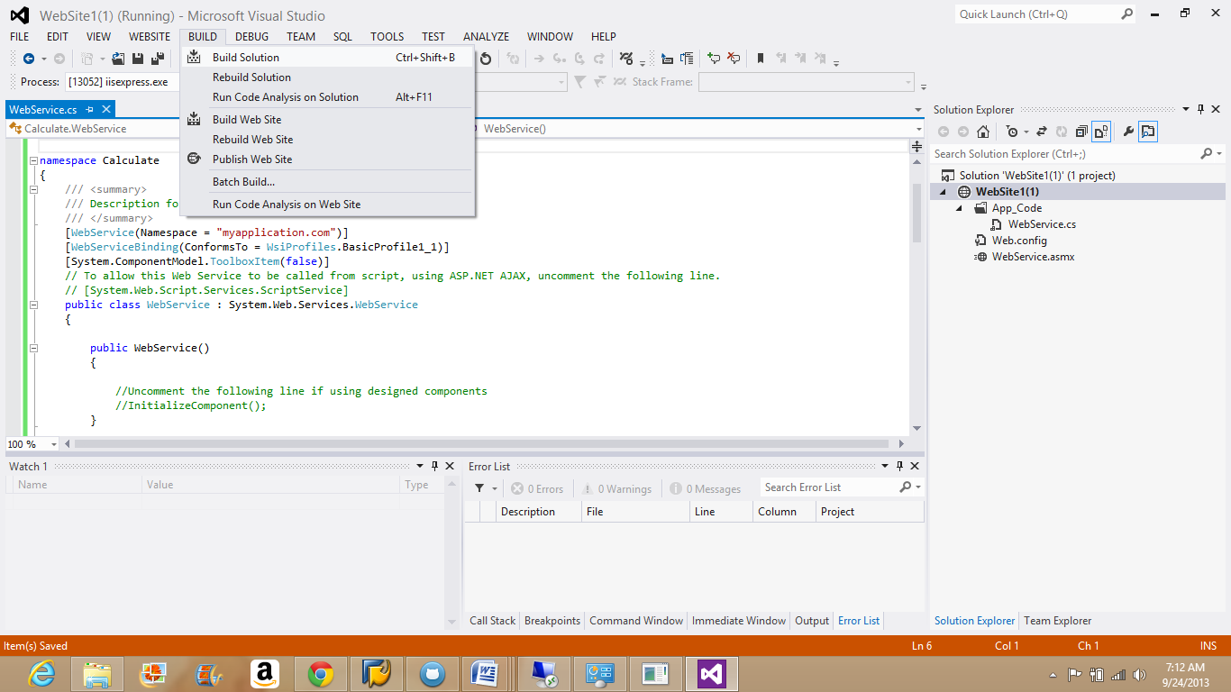

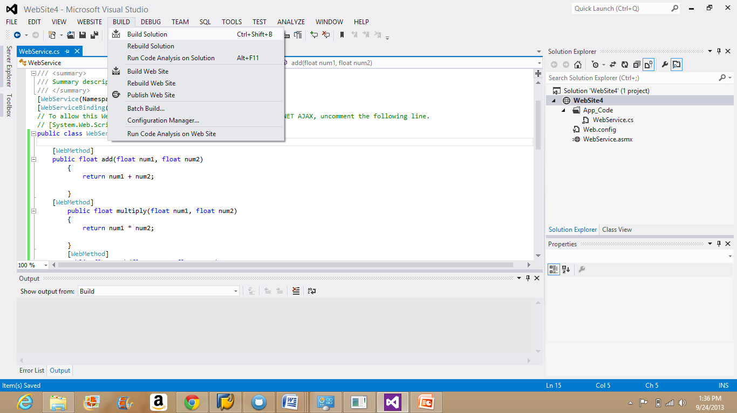

The code without errors gets build up and will be shown in the Output window, the one present below to the editor.

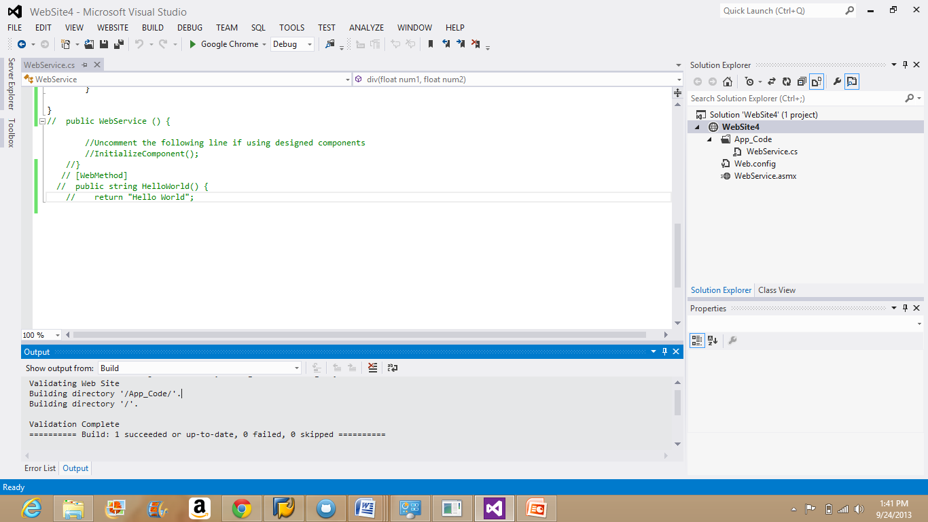

Once code is build, start the code without debugging.

Go to Menu Debug-Start without Debugging.

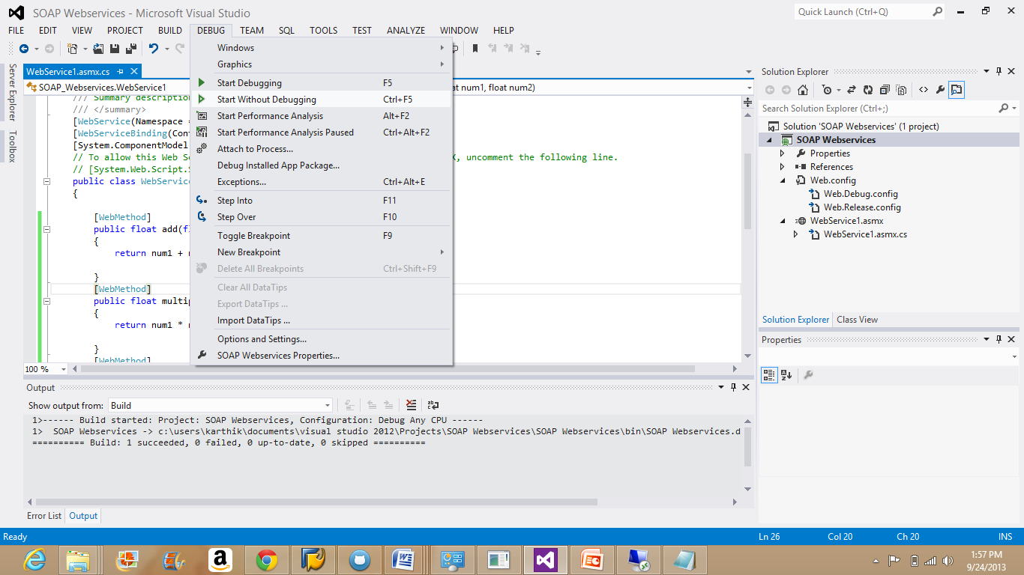

Right Click on the Web Service and choose open with browser option.

The following window gets displayed.

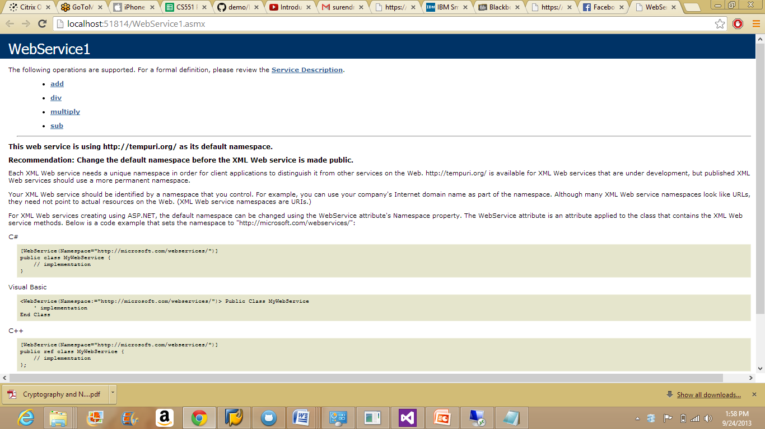

The below are the outputs of the basic arithmetic operations invoking and their results.

**Addition:**

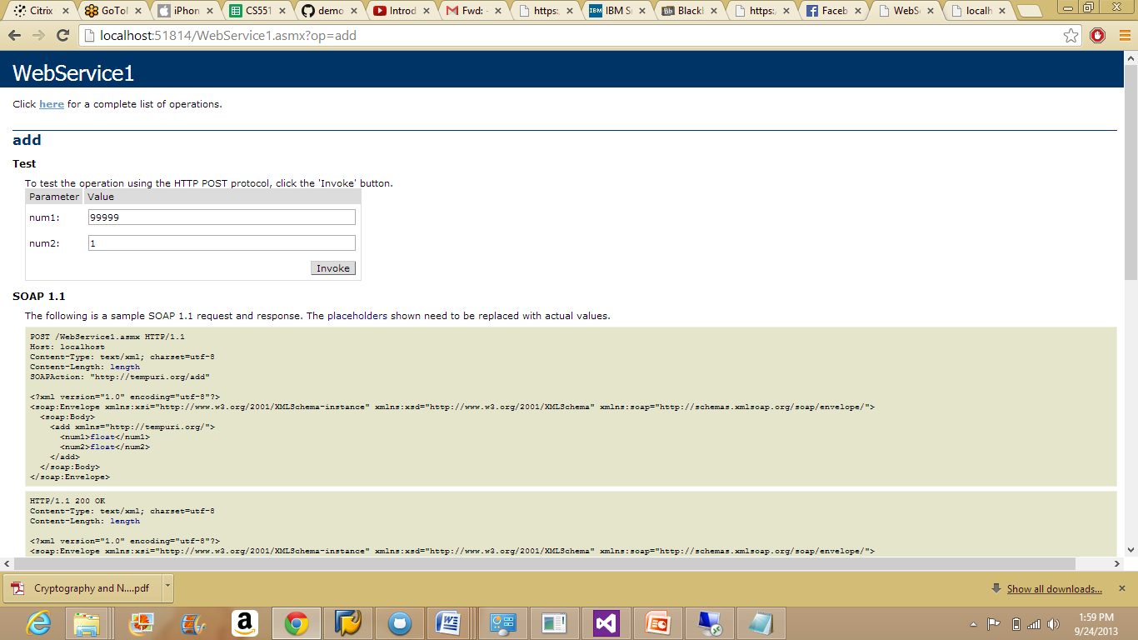

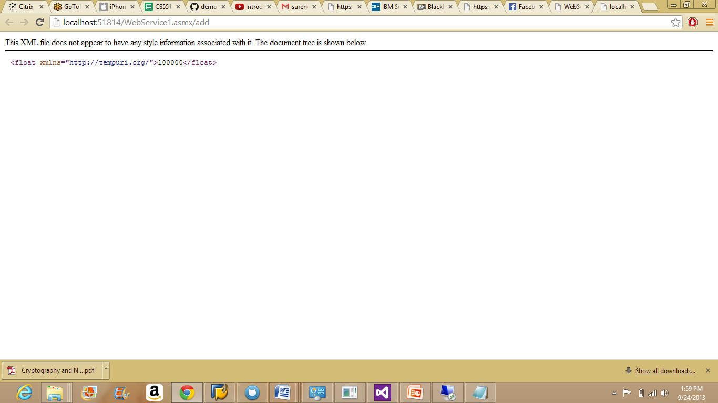

**Division:**

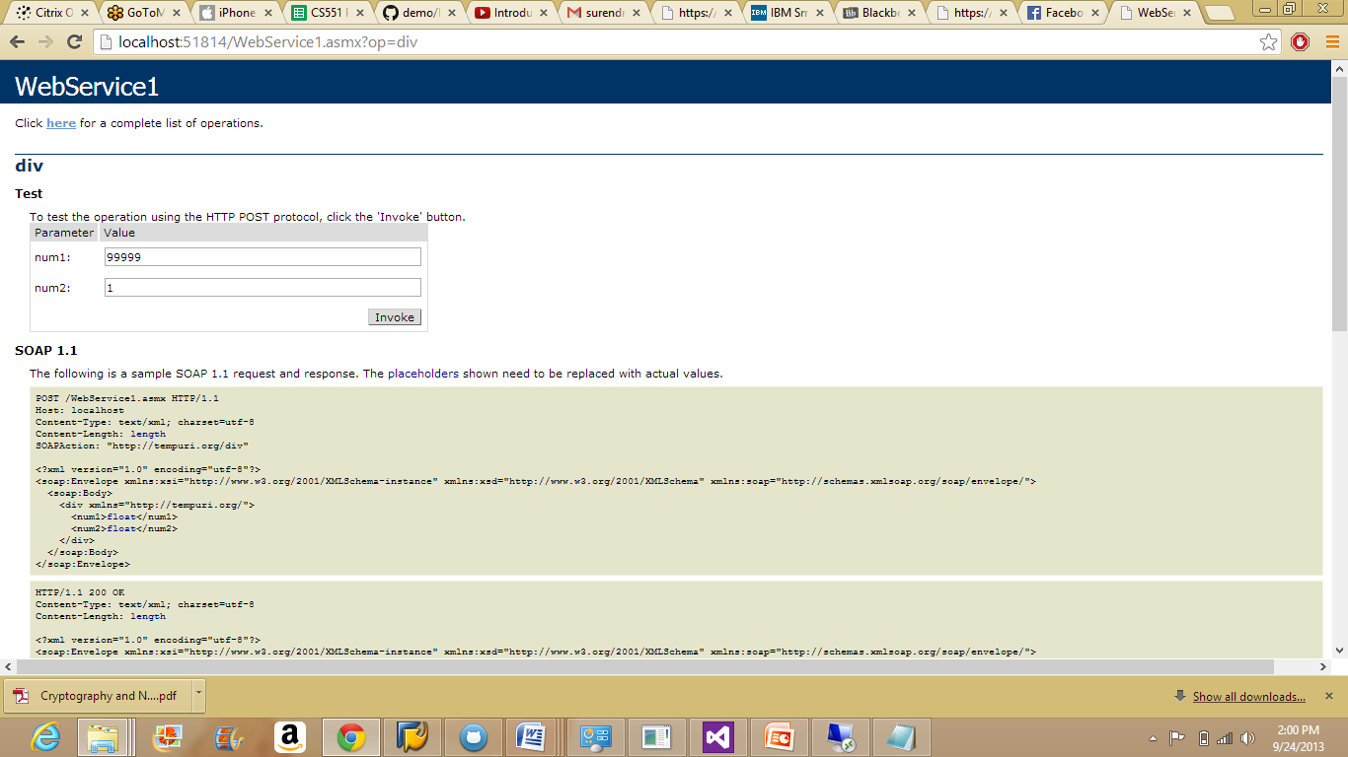

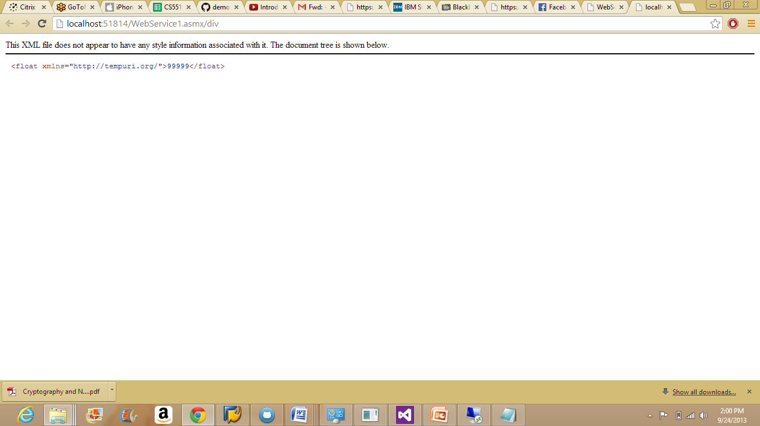

**Multiplication:**

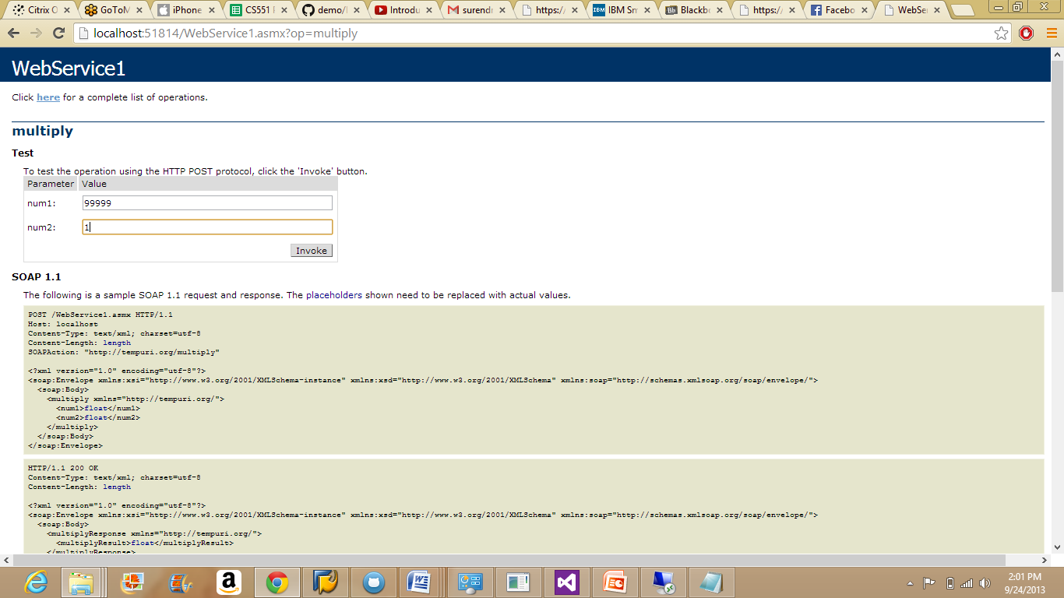

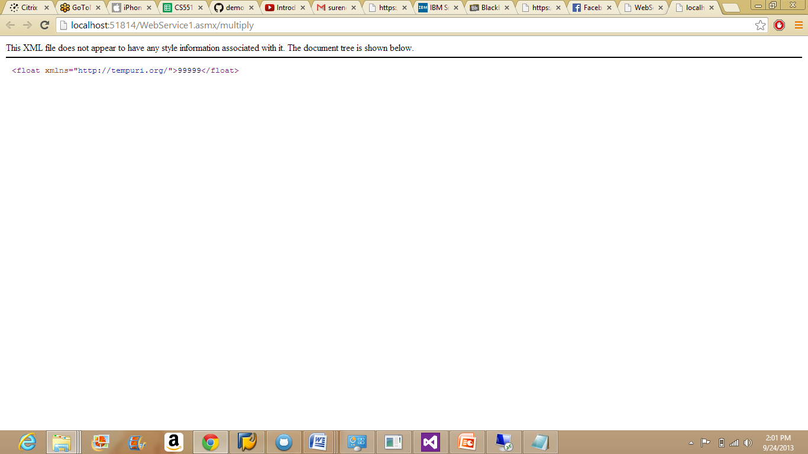

**Subtraction:**

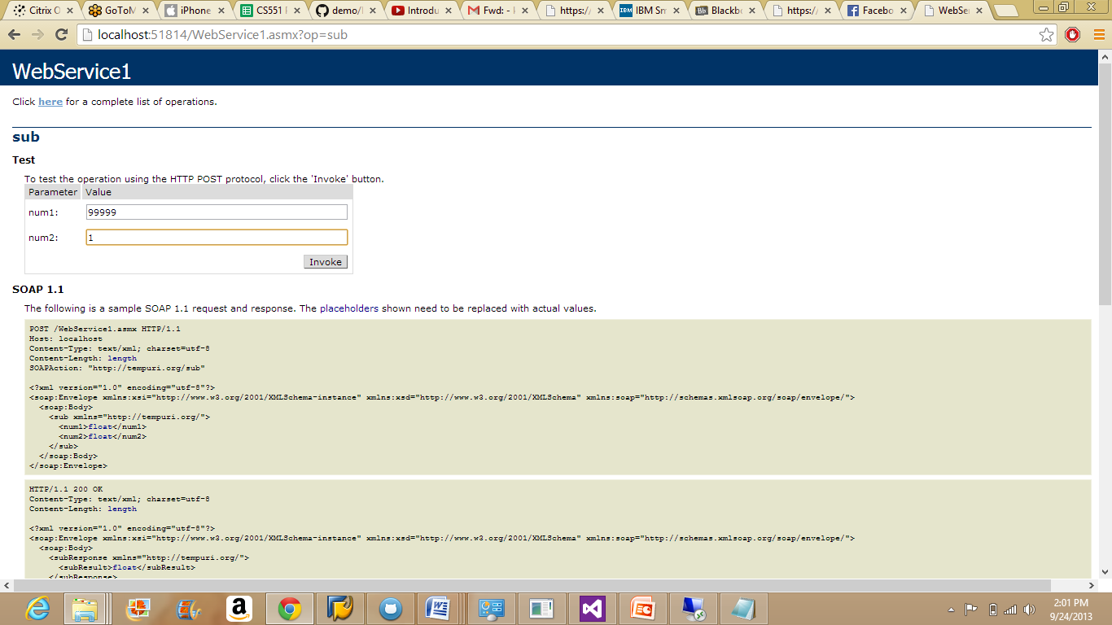

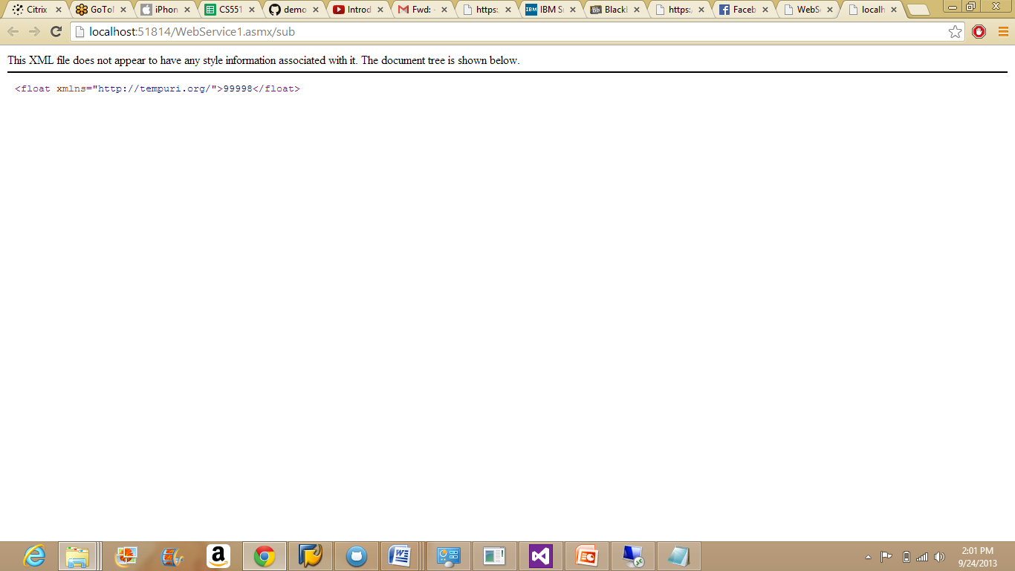

Copy the Soap Services created in the local copy and deploy the same code in the remote instance.

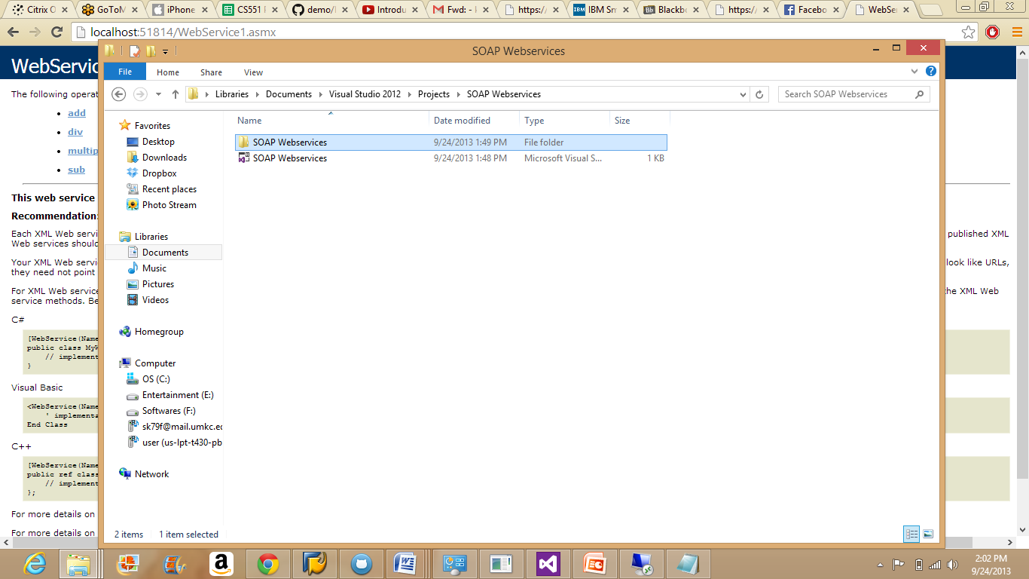

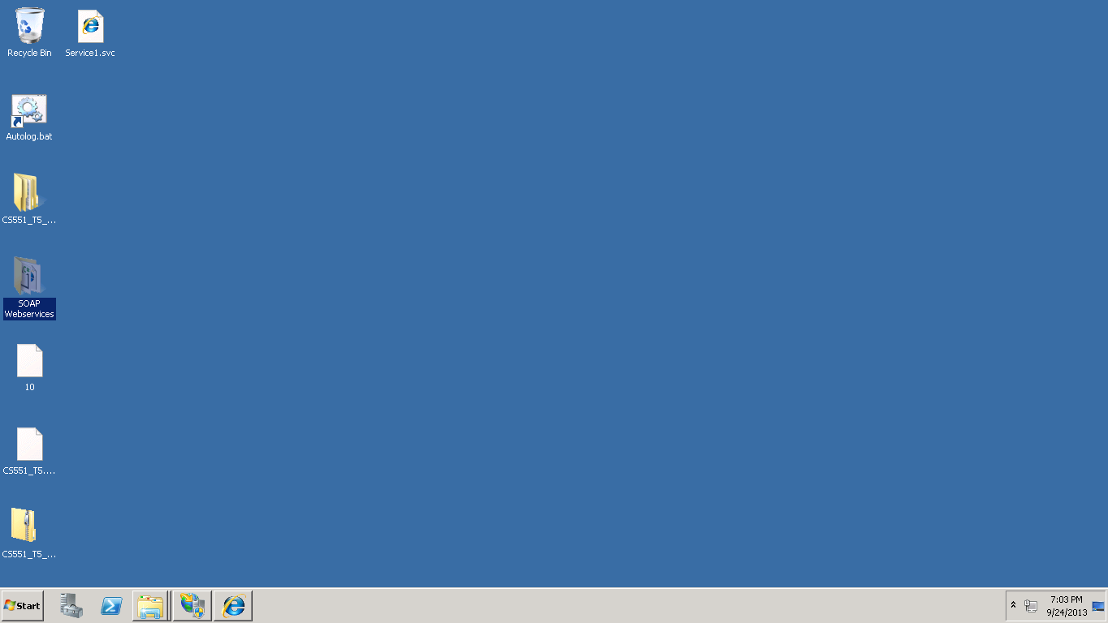

Go the IIS Manager and convert the SOAP service into an application.

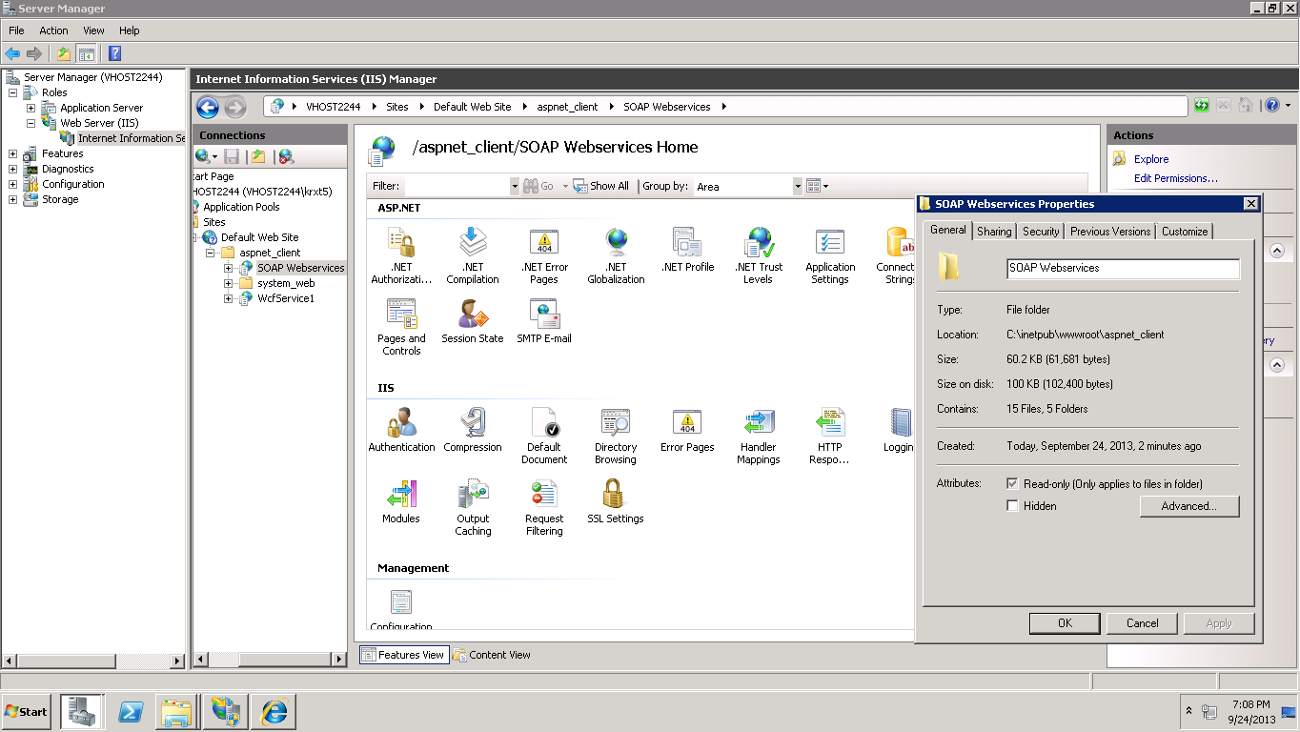

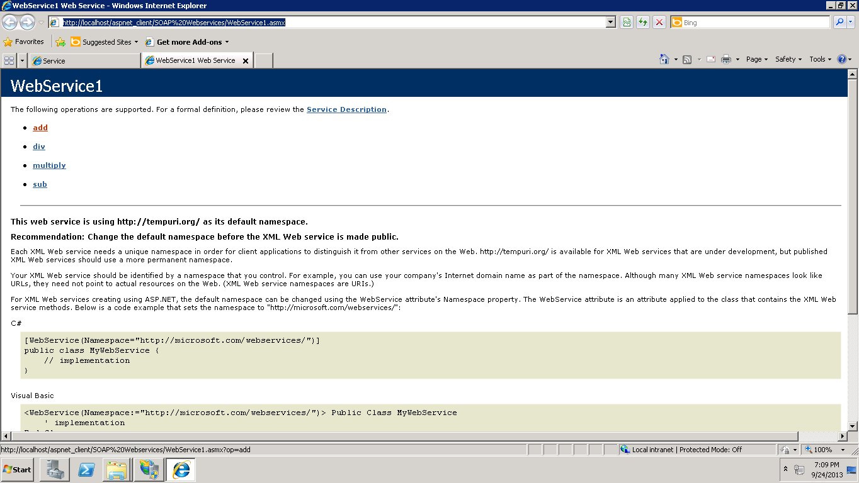

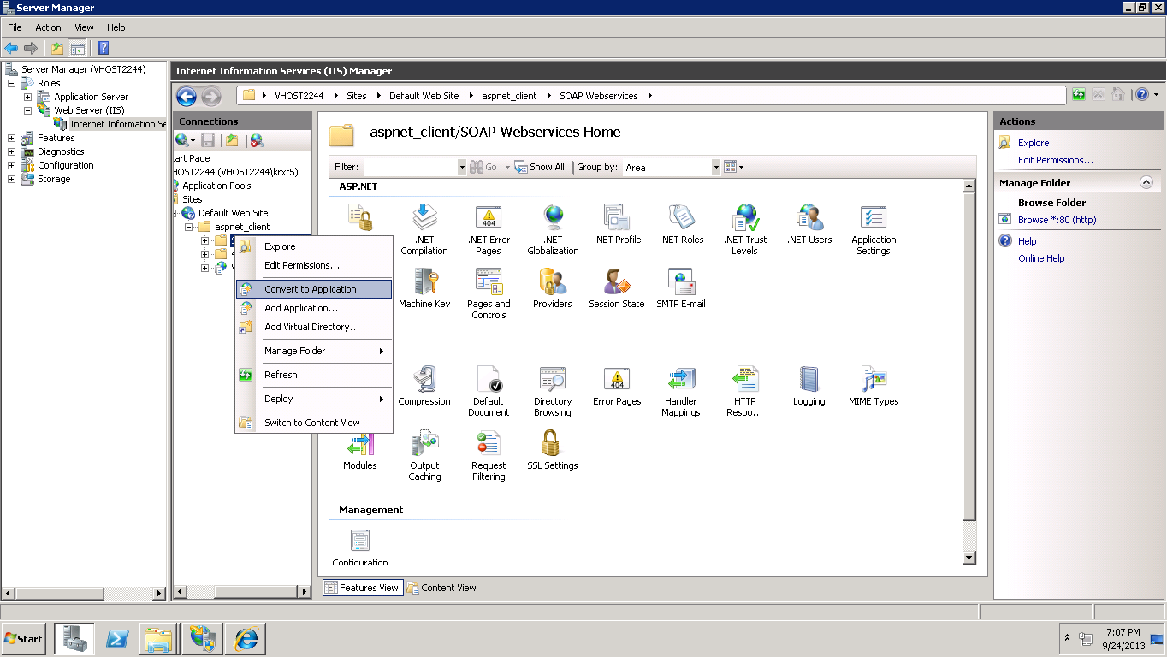

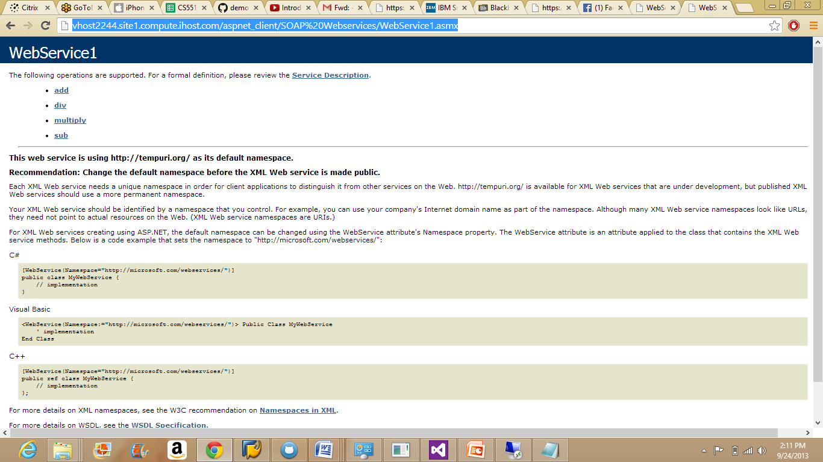

**RESTFUL WEBSERVICES**

Go to the menu and create an WCF Service application.

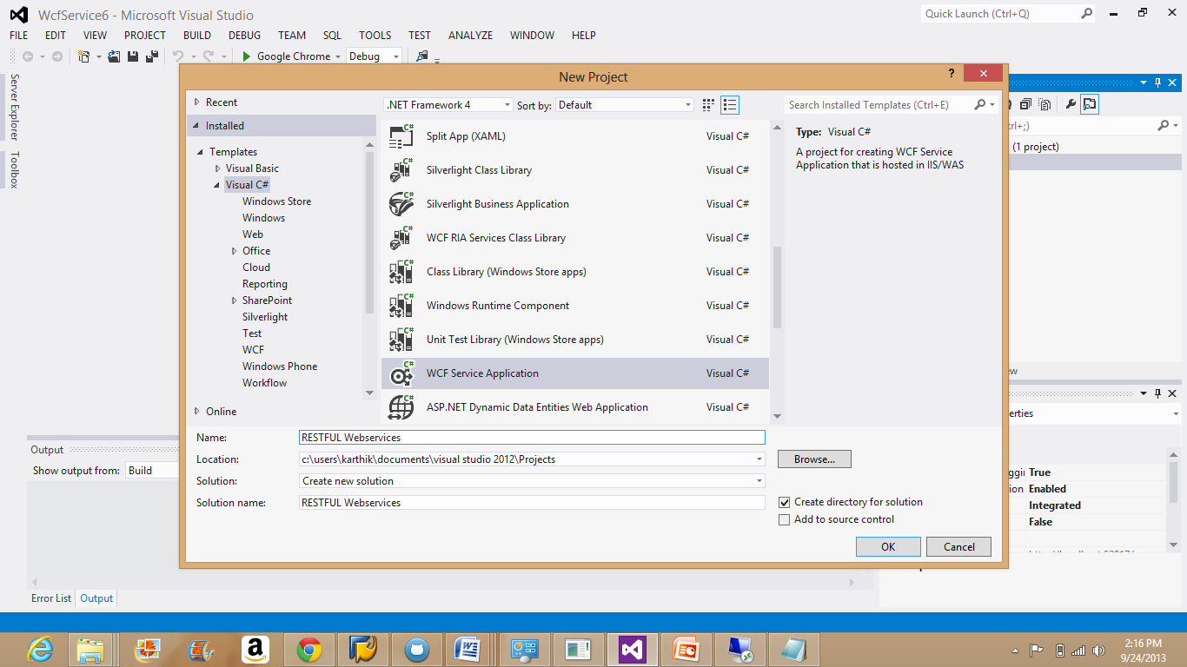

Code as per the requirement in the editor.

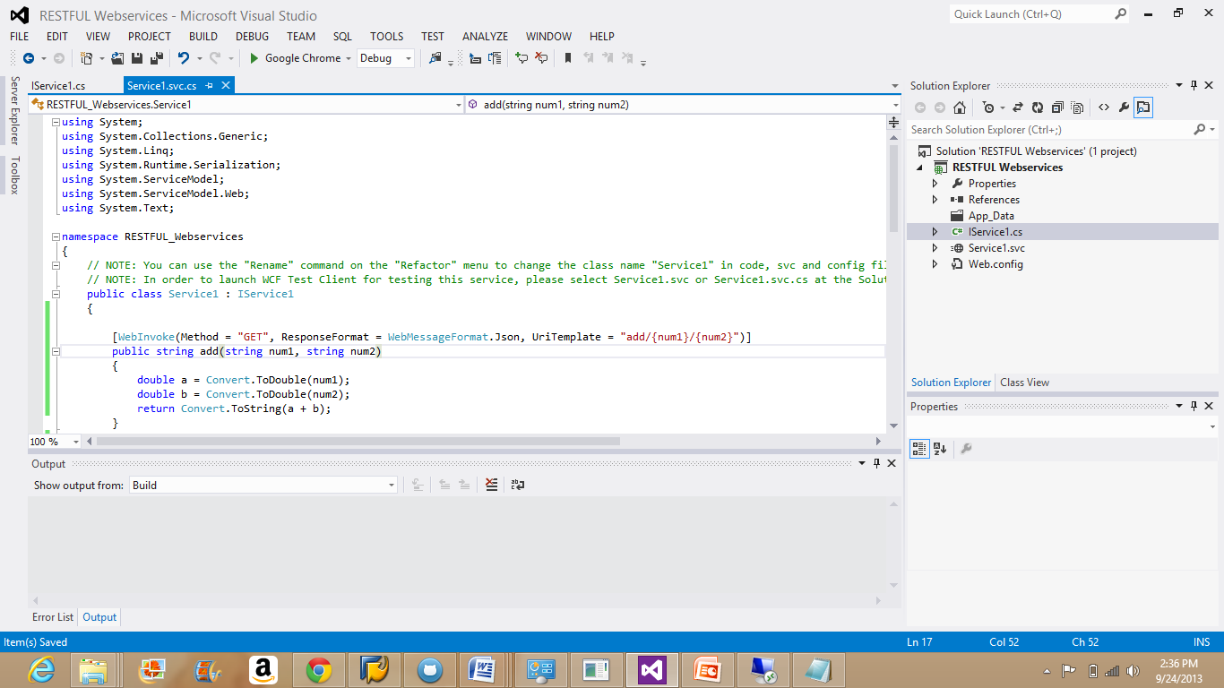

Build the code again by going into the menu Build--Build Solution.

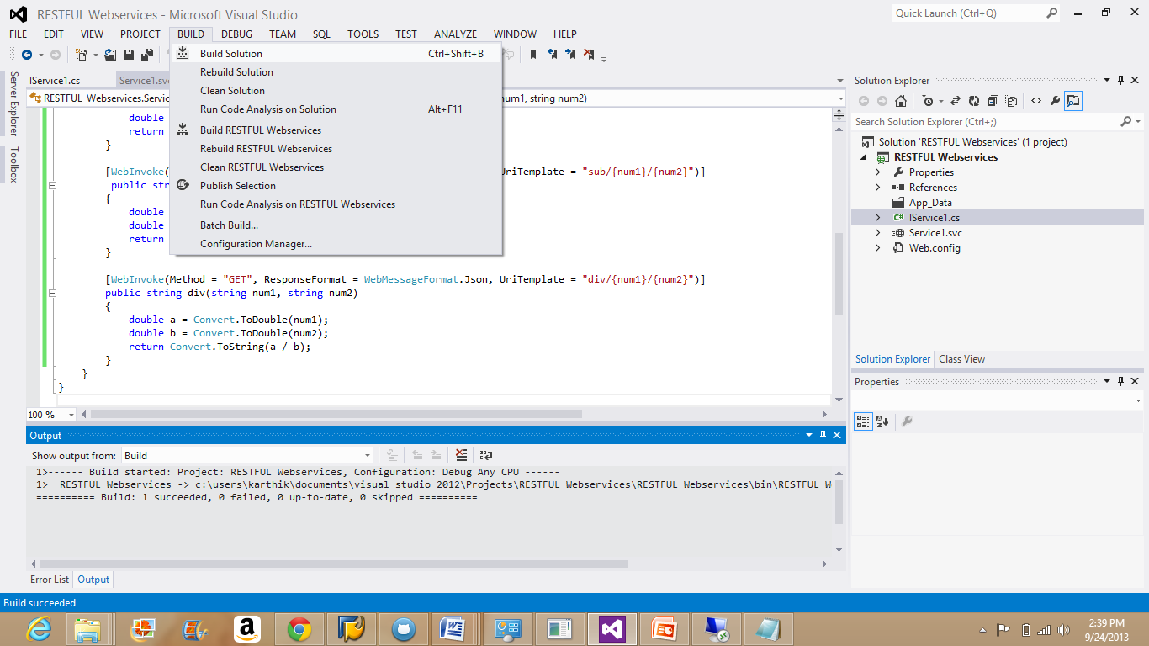

Once code gets build, debug the code by selecting the option "start without debugging".

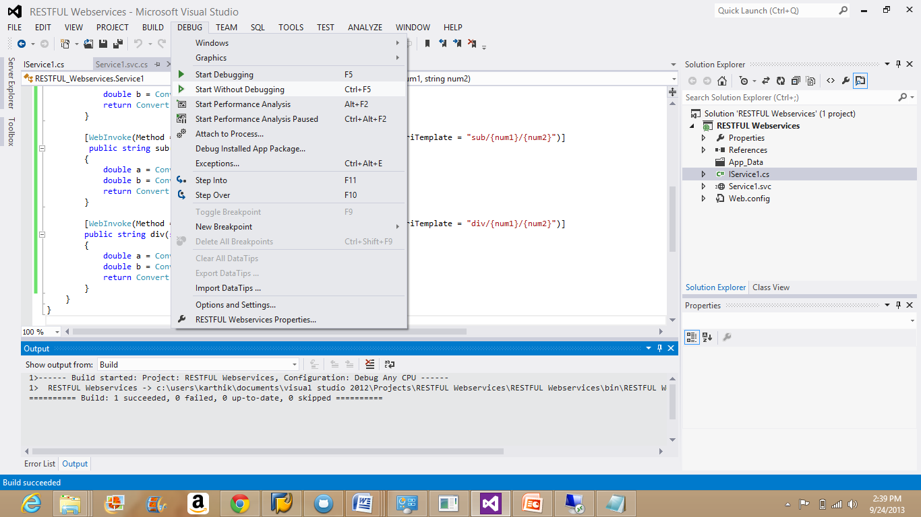

Right Click on the Service application and choose "view in browser".

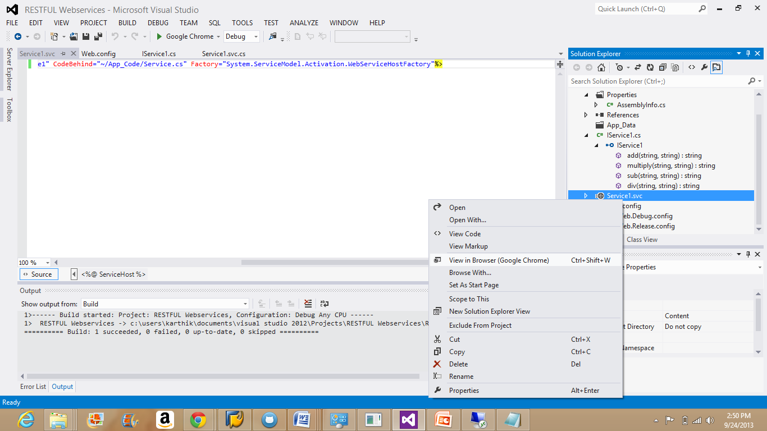

The value gets displayed when the input fields are given in the URL.

**Division:**

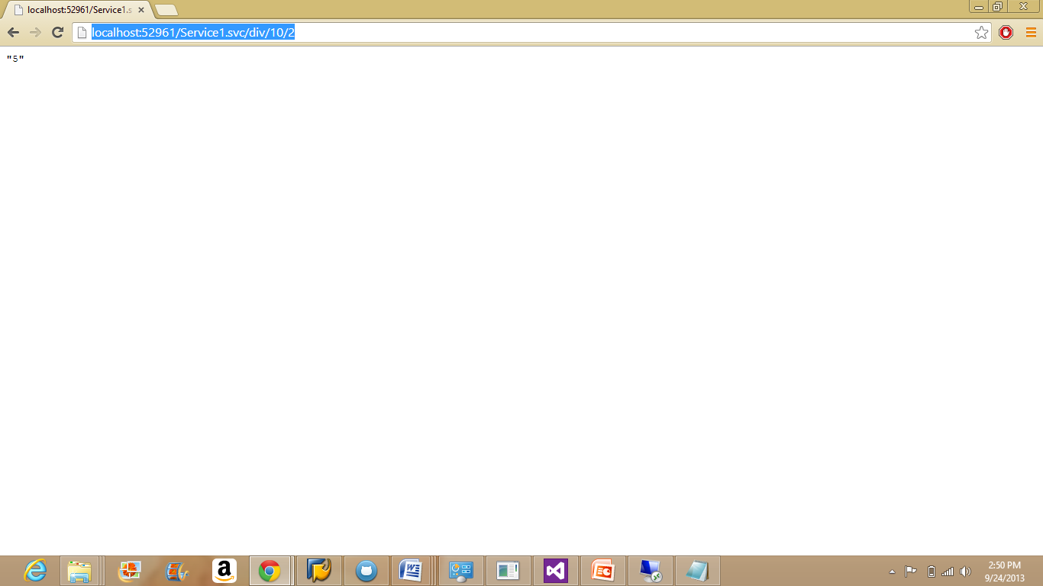

**Addition:**

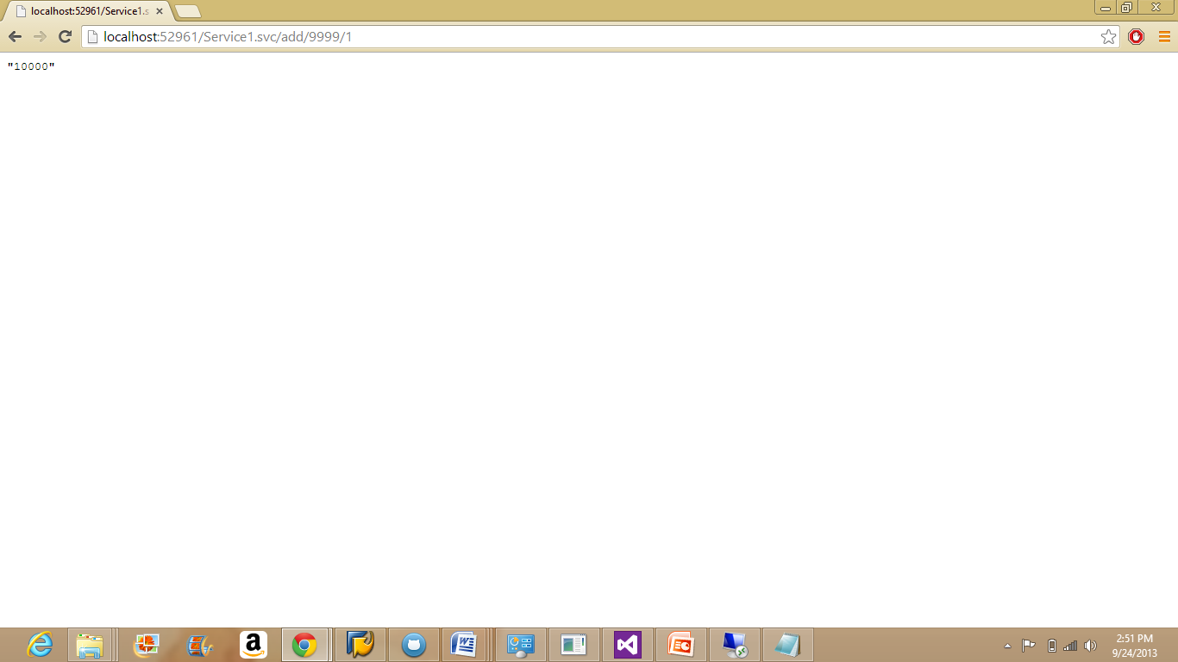

**Multiplication:**

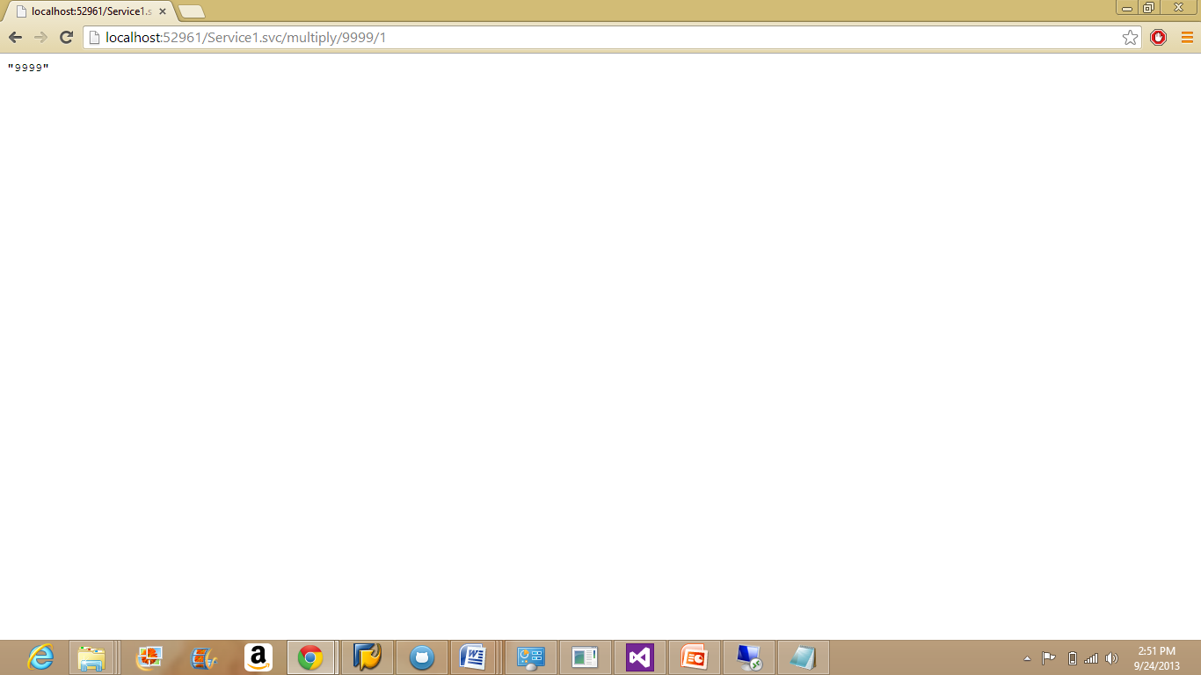

**Subtraction:**

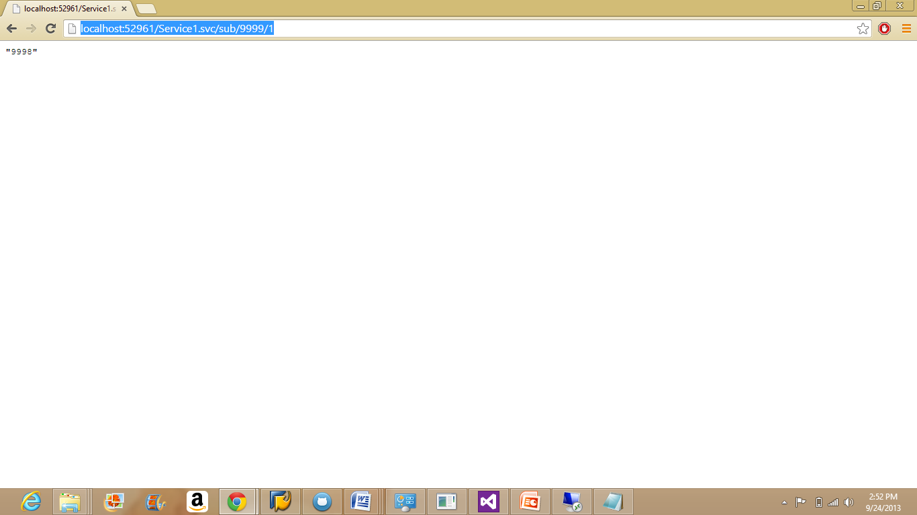

Copy the source code of Restful services into the cloud instance.

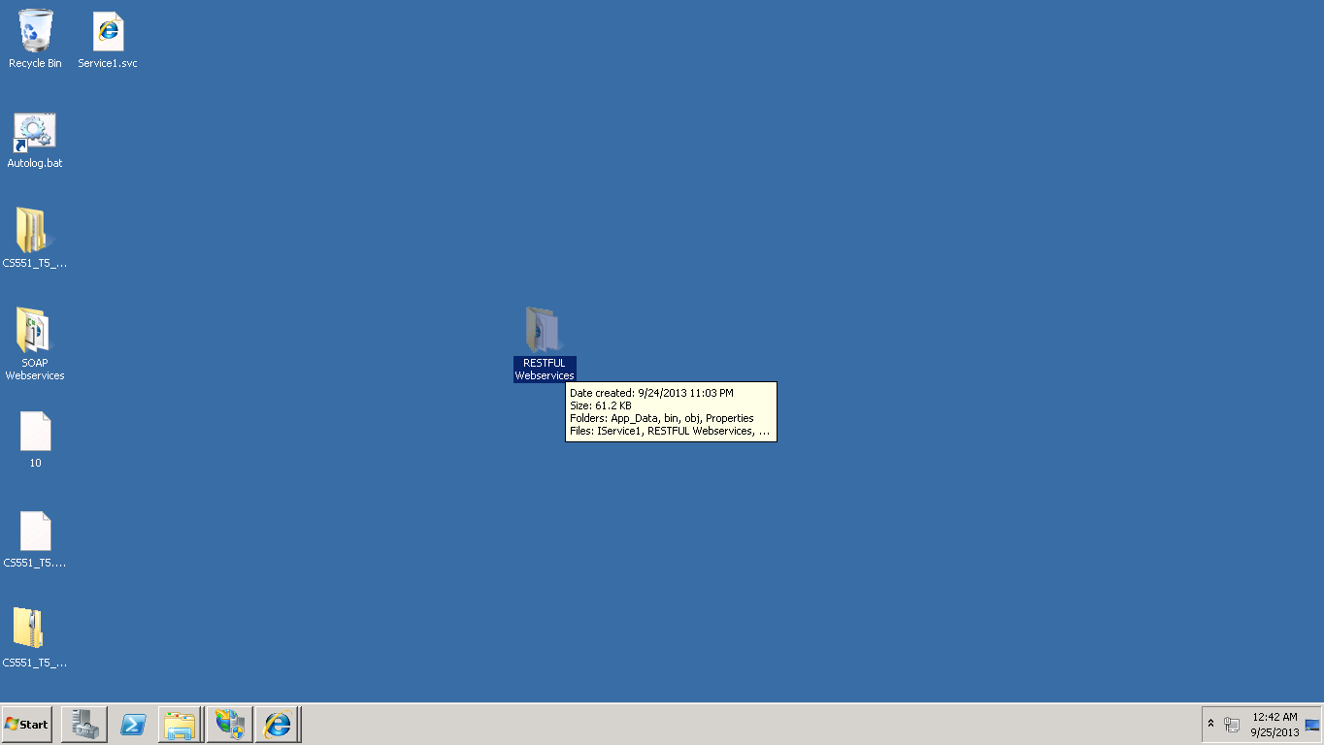

Deploy the restful services in to the remote cloud instance as the way SOAP web services are installed.

Now, convert the Restful services into an application by following the same steps used for SOAP services.

The below picture shows the SOAP and Restful services deployed into the remote instance and converted them to applications.

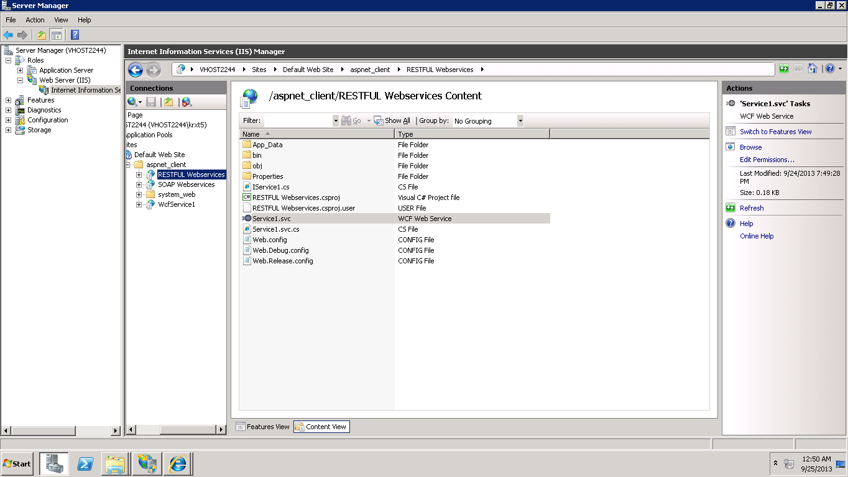

This will complete creating SOAP and Restful Web services.

The next step is to create the Web form and define the screen.